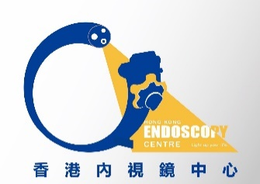
Room 1725A, 17 th floor, phase I, The Grand Plaza Mong Kok, Kowloon Tel: 23532180 Fax 2352 2666
Hong Kong Endoscopy Centre

Account Opening Form

Doctor Name: _____________________________ (Chinese_______________________)
Endoscopy Privilege to any private hospital in Hong Kong:
OGD_______Colonoscopy______ Cystoscopy______ ESD______ EUS______ (please tick)
Which Hospitals? ___________________________________________________________
Certificate copies attached: A.P.C________ M.P.S_________ Specialty: ______________
Use company name on bill? __ Y ____N Company Name__________________________
Business Registration Number: (if any)___________________________________________
Clinic Address______________________________________________________________
Tel No: _________________________ Fax No: _________________________________
E-mail: _________________________Emergency contact mobile No.:__________________
Contact person for billing matters: _________________________ Tel No.:_______________
Billing or A/C Dept. address (if different to clinic address):
___________________________________________________________________________

The Doctor agreed to pay the Centre within 30 days of the invoice by cheque or by bank deposit:
1/ By Cheque:
Cheque payable to “Hong Kong Endoscopy Centre”

2/ Bank Deposit: Name of Bank: Bank of China (Hong Kong) Limited
Account Name: Hong Kong Endoscopy Centre
Account Number: 012-586-00105471

Doctor’s Signature___________________________ Date: _________________________

Please complete and return this form, with your name card and a copy of your certificates of Business registration, Medical Protection Society and Annual Practicing Certificate to the Centre by mail or fax.

