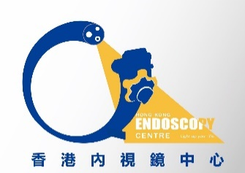
Room 1725A, 17 th floor, phase I, The Grand Plaza Mong Kok, Kowloon Tel: 23532180 Fax 2352 2666
Hong Kong Endoscopy Centre

Endoscopist Booking Form D
Booking Information
Appointment Date: _________________
Prefer Time:______________________
Operations: (please tick)
OGD_____ Colonoscopy_____ Cystoscopy_____ ESD_____ EUS_____ Capsule Endoscopy_____
Is anesthetist required? ____Y ____N
Remark: ________________________________________________________________
________________________________________________________________________

Endoscopist’s Information
Endoscopist’s name: _______________________________________________________
Company name: ___________________________________________________________
Address: _________________________________________________________________
Tel: ____________________________ Fax: _______________________________

