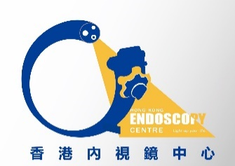
Room 1725A, 17 th floor, phase I, The Grand Plaza Mong Kok, Kowloon Tel: 23532180 Fax 2352 2666
Hong Kong Endoscopy Centre

Non-Endoscopist Referral Form C
Appointment Date: _________________
Prefer Time:______________________
Estimated Arrival Time: _____________
Patient’s Information
Name: ____________________________ 中文姓名: __________________________
Performing Procedures: OGD / COLON / Others: ________________________________
Sex: M / F D.O.B: ______________(dd/mm/yyyy) HKID: ___________________
Address: _________________________________________________________________
_________________________________________________________________________
Email address: ____________________________________________________________
Phone: ________________ Mobile: _________________ Home: ________________
Emergency contact: ____________________ Relationship ________________________
Emergency contact number: _______________________
Past Medical History: _______________________________________________________
_______________________________________________________
Chronic Diseases: Diabetes / Hypertension / Cardiac diseases / Respiratory diseases /
Hepatitis / Others: ________________________________________
Allergy: __________________________________________________________________

Non-Endoscopist’s Information
Non-Endoscopist’s name: ____________________________________
Company name: __________________________________
Address: _________________________________________________________________
Tel: ____________________________ Fax: _______________________________
Choice of Endoscopists: Choice of Anaesthetist:
- __________________________ 1. __________________________
- __________________________ 2. __________________________
- __________________________ 3. __________________________

